# **Frecuencia**

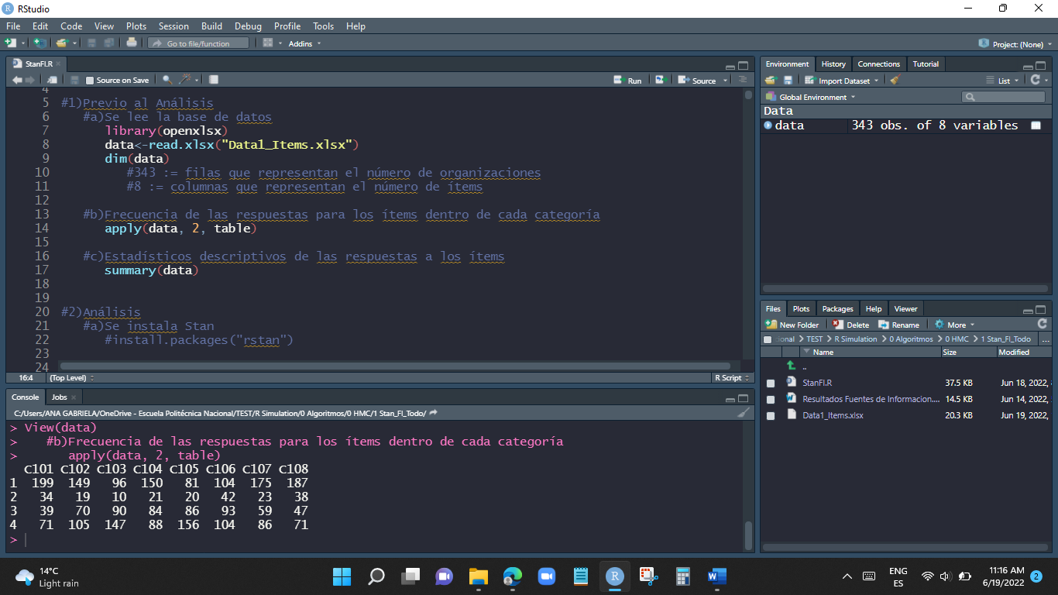

# **Estadísticos Descriptivos**

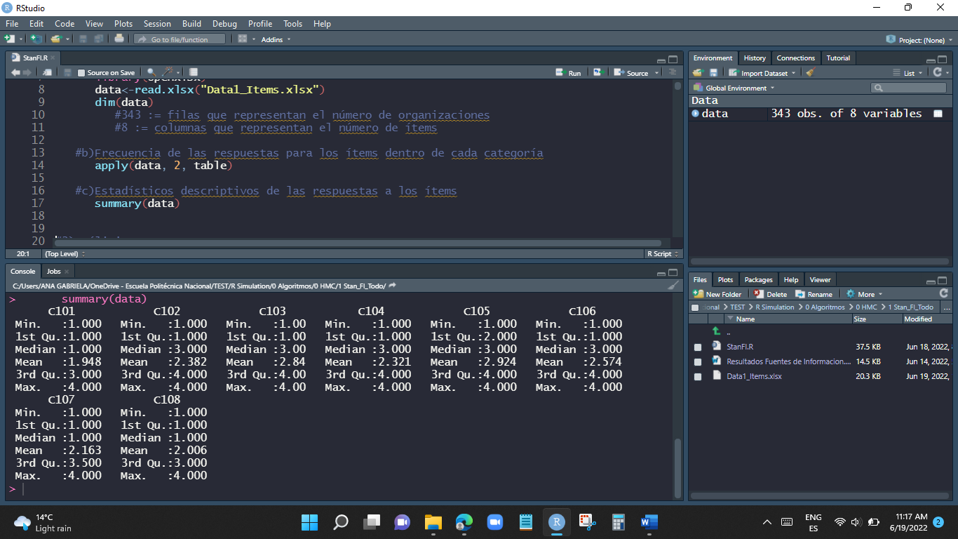

**Leer la librería rstan**

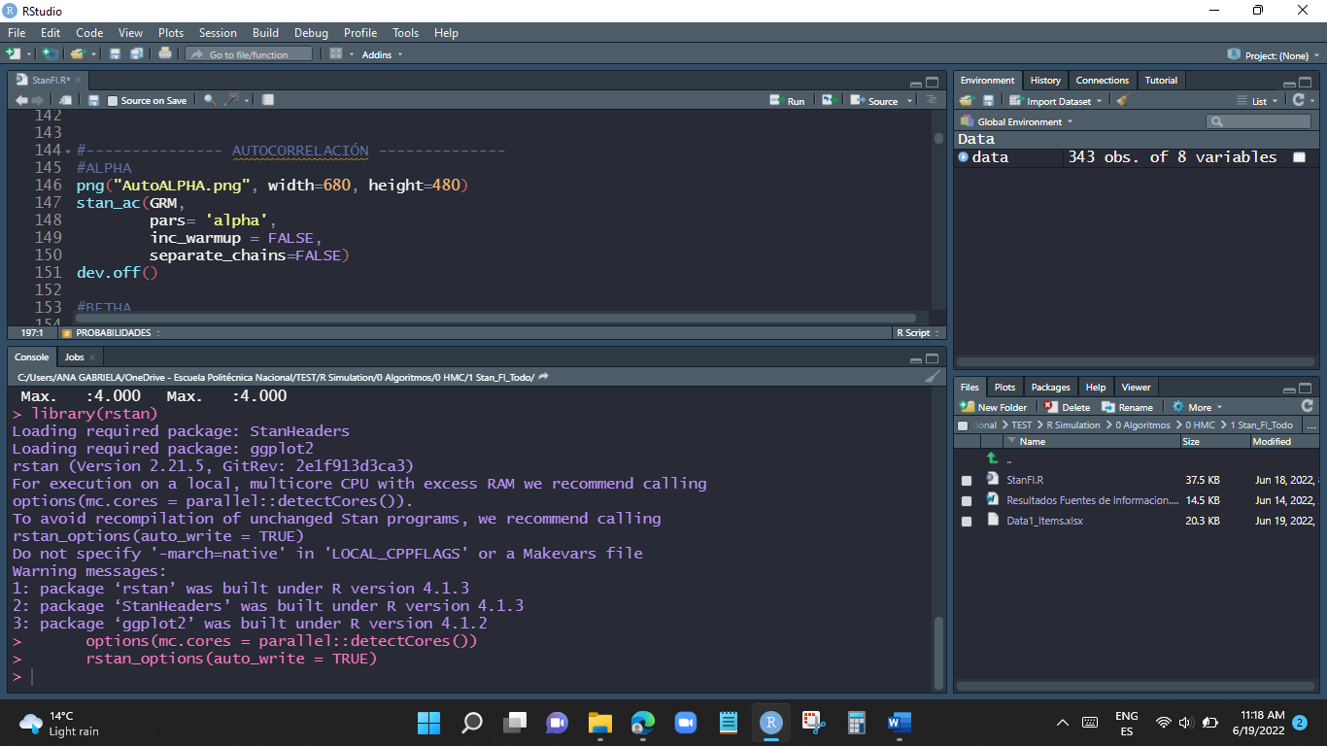

Loading required package: StanHeaders

Loading required package: ggplot2

rstan (Version 2.21.5, GitRev: 2e1f913d3ca3)

For execution on a local, multicore CPU with excess RAM we recommend calling

options(mc.cores = parallel::detectCores()).

To avoid recompilation of unchanged Stan programs, we recommend calling

rstan_options(auto_write = TRUE)

Do not specify '-march=native' in 'LOCAL_CPPFLAGS' or a Makevars file

Warning messages:

1: package ‘rstan’ was built under R version 4.1.3

2: package ‘StanHeaders’ was built under R version 4.1.3

3: package ‘ggplot2’ was built under R version 4.1.2

# **Leemos GRM**

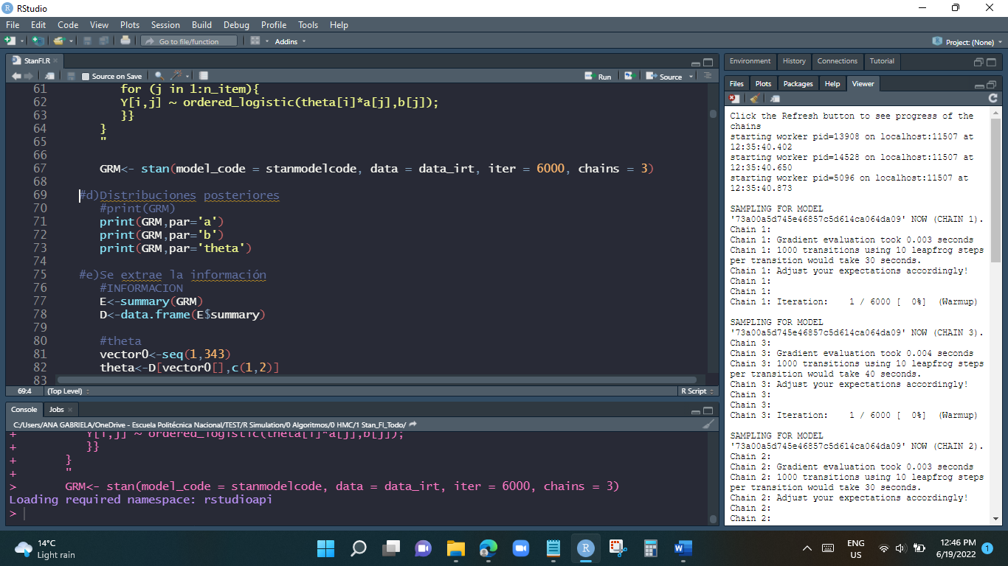

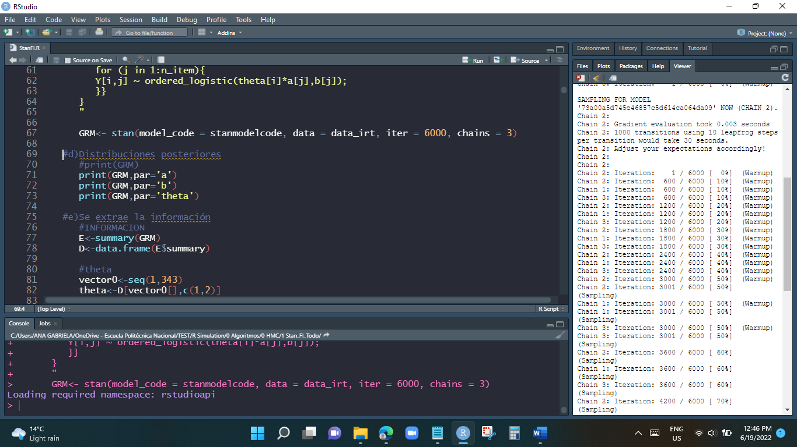

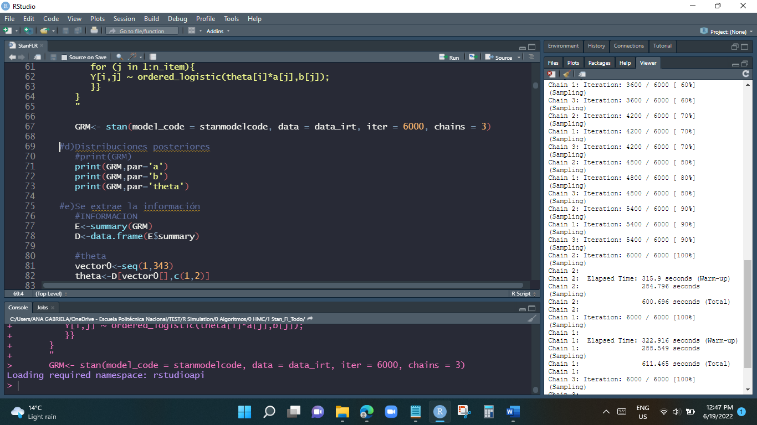

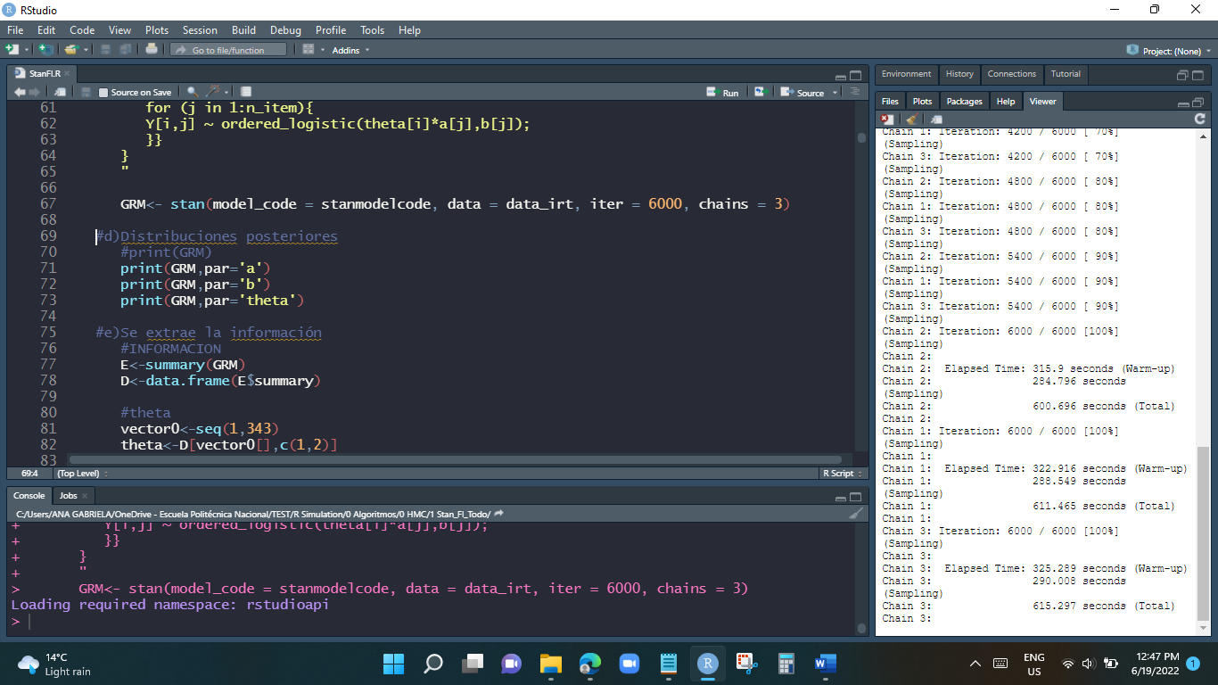

# **print(GRM,par='alpha')**

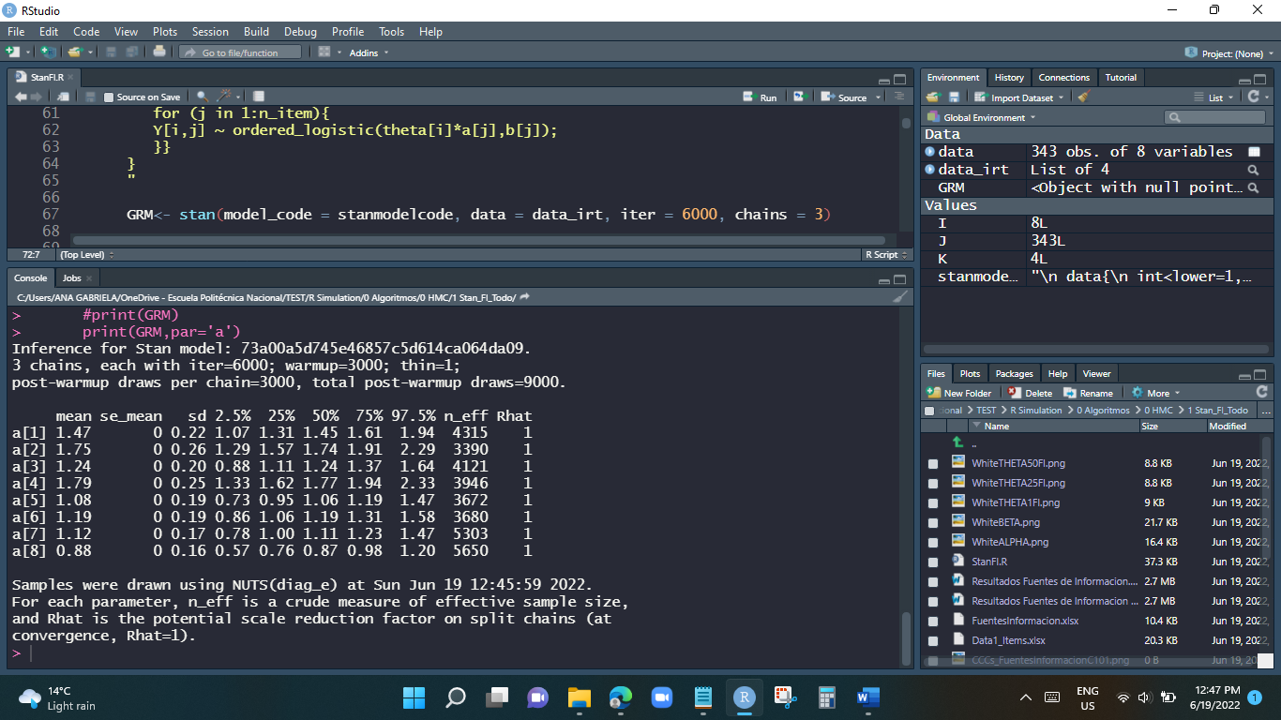

# **print(GRM,par='beta')**

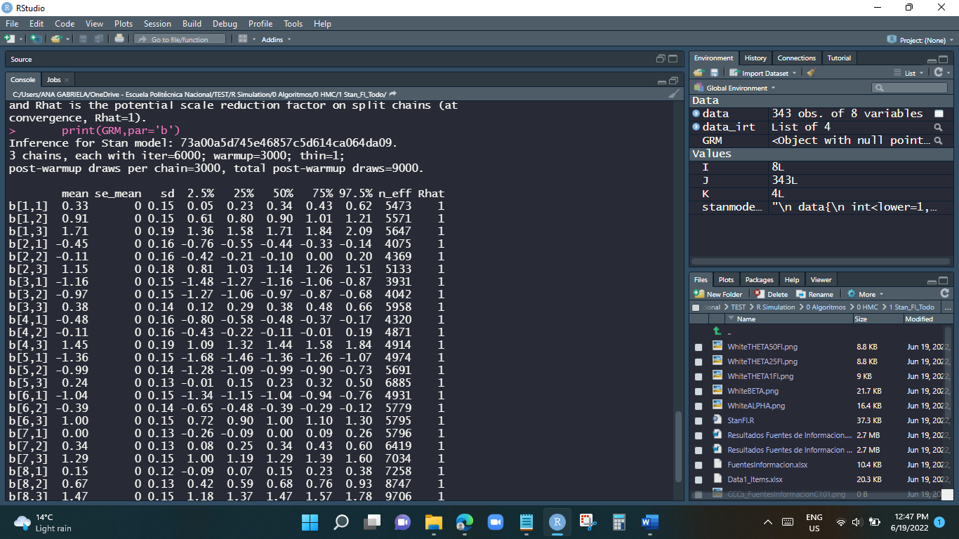

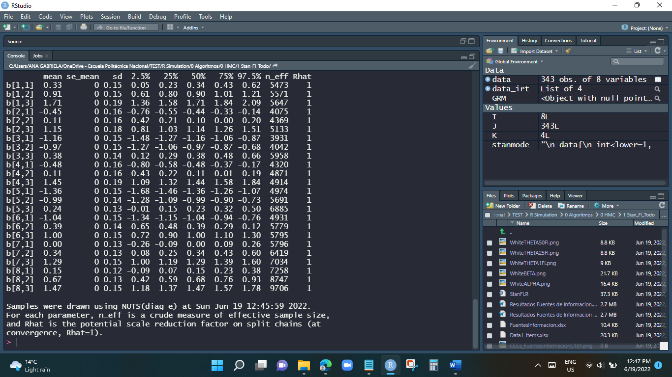

# **print(GRM,par='theta')**

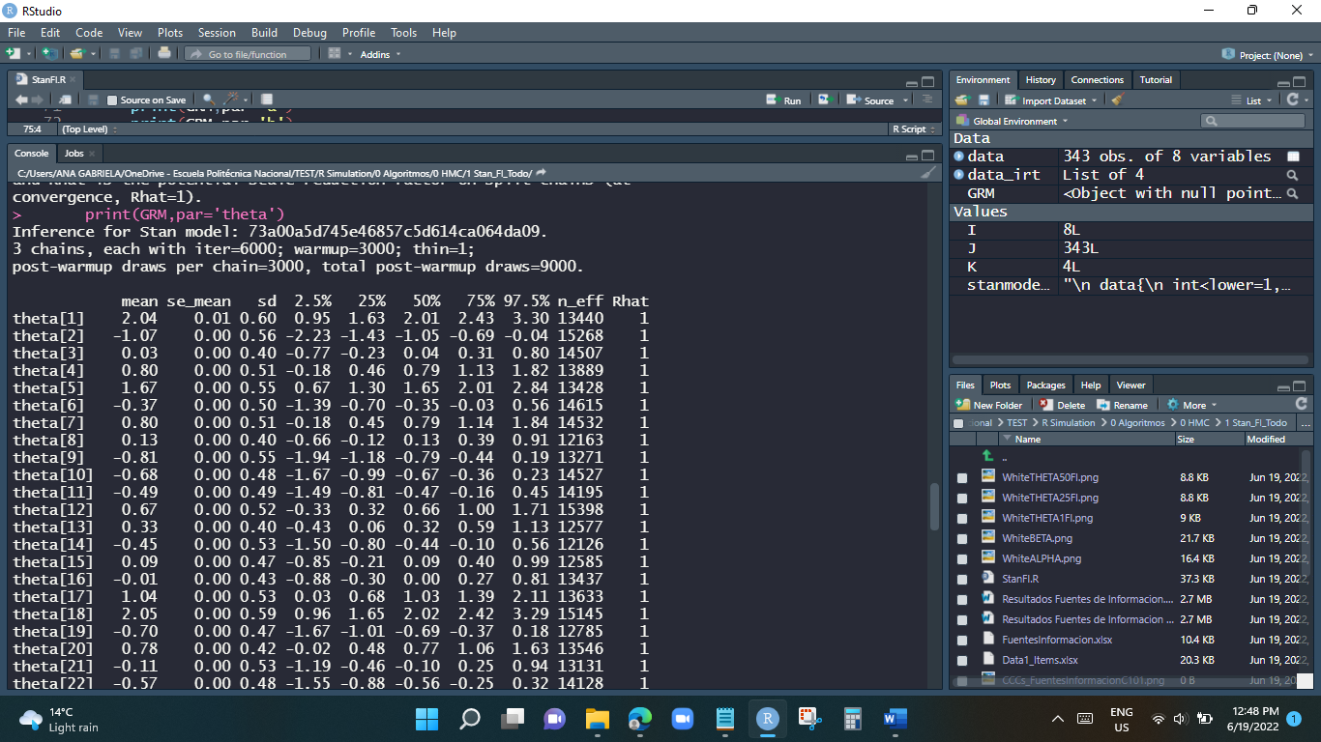

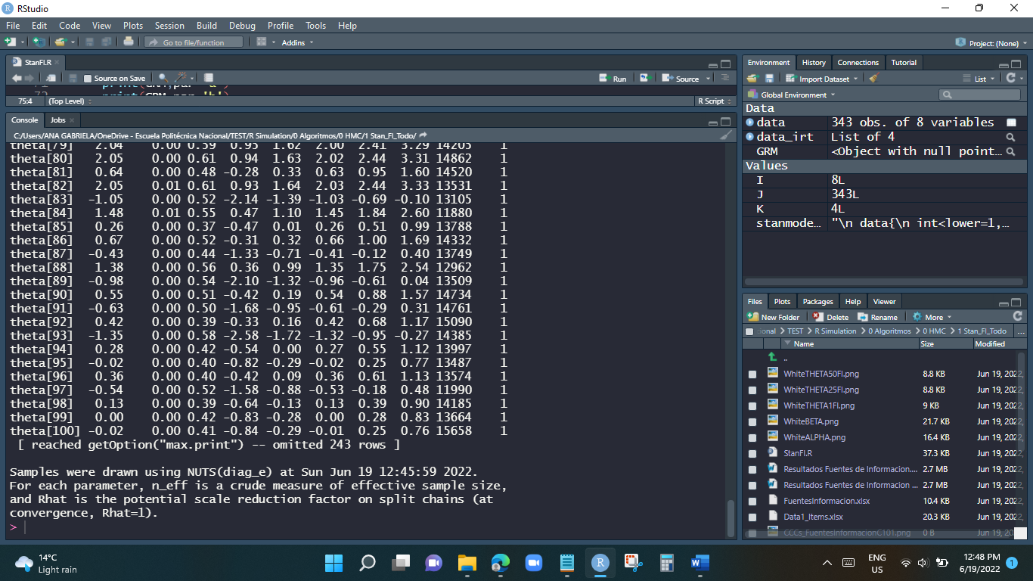

# **White noise**

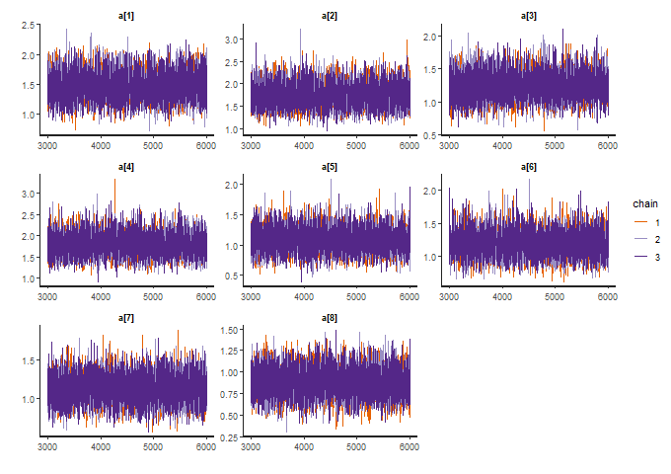

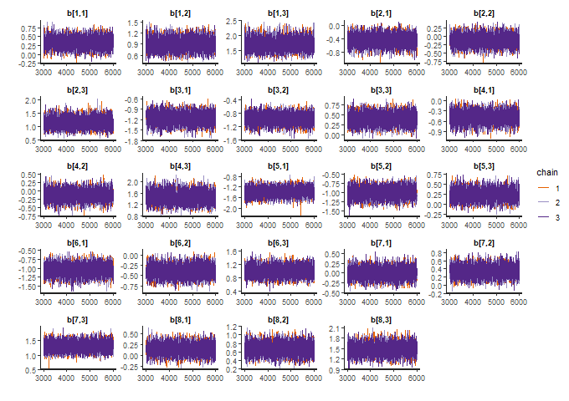

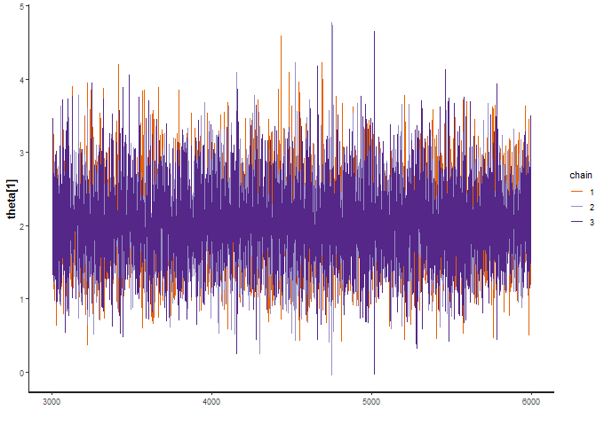

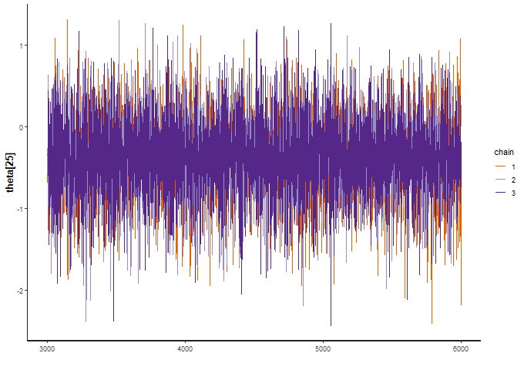

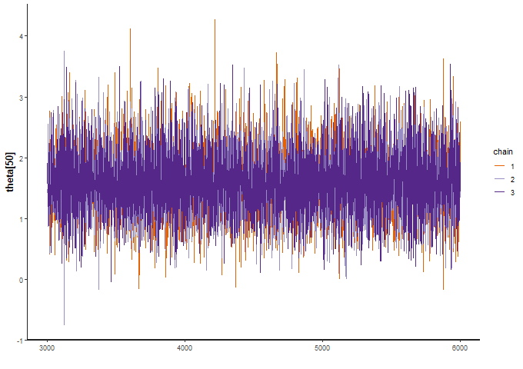

# **Autocorrelacion**

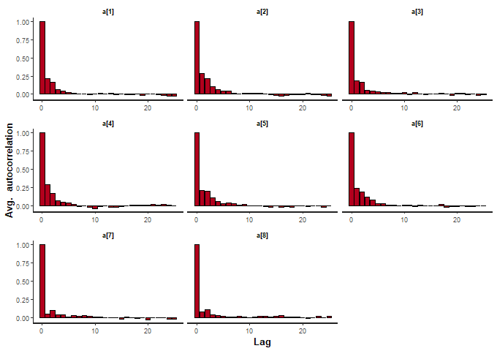

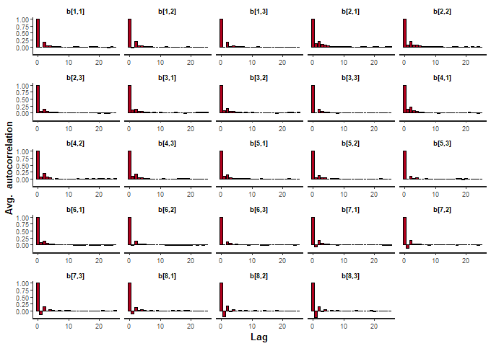

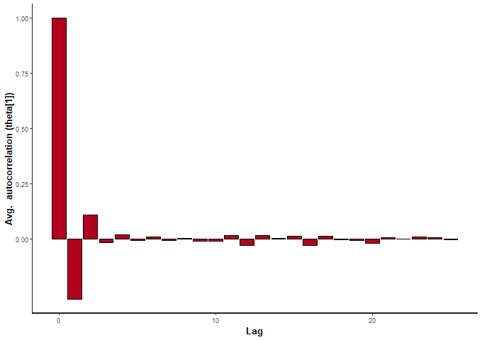

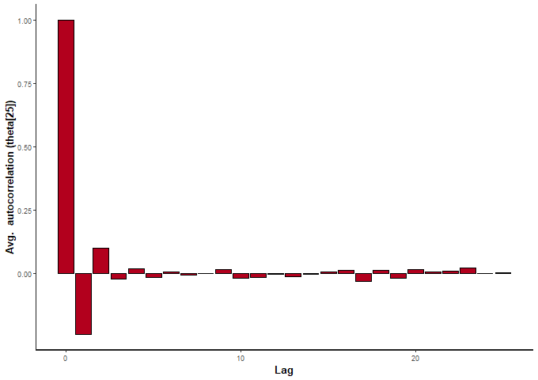

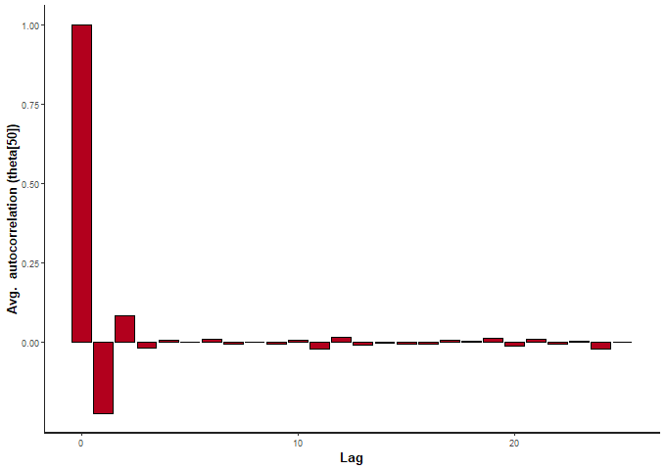

# **Resultados de las Probabilidades y Habilidad**

# **CCCs Curvas Caracteristica**

## C101

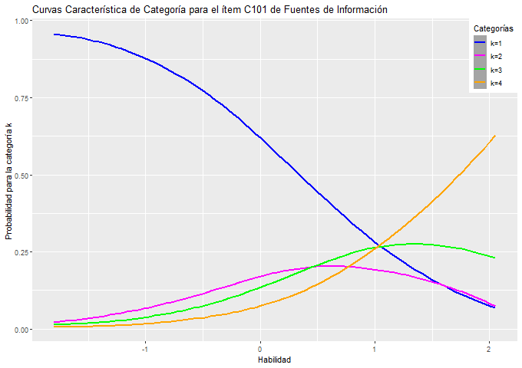

## C102

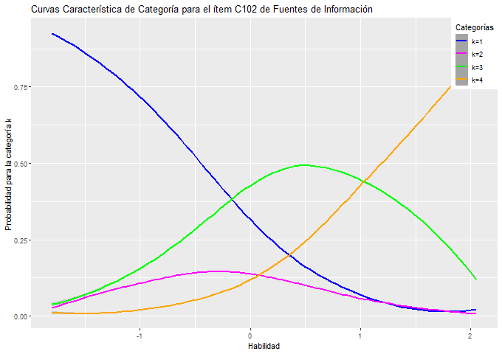

## C103

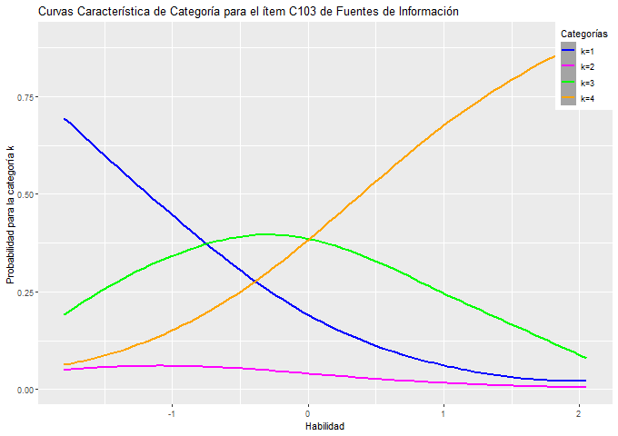

## C104

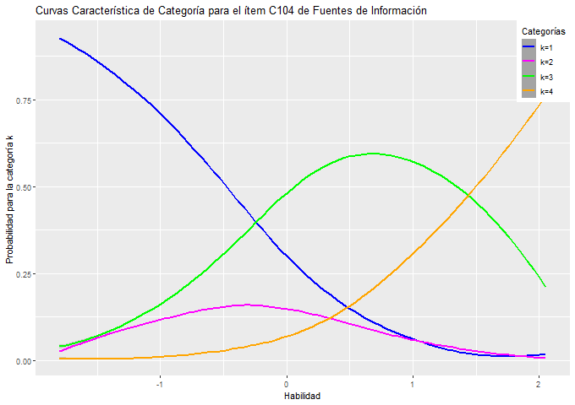

## C105

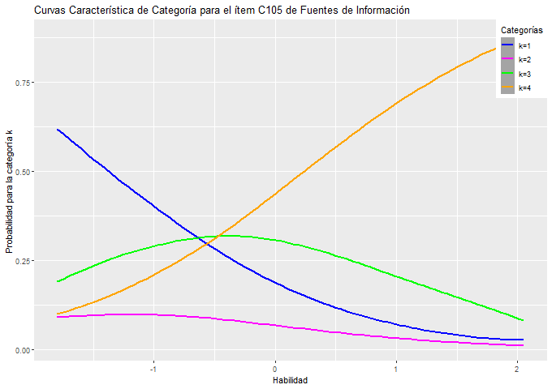

## C106

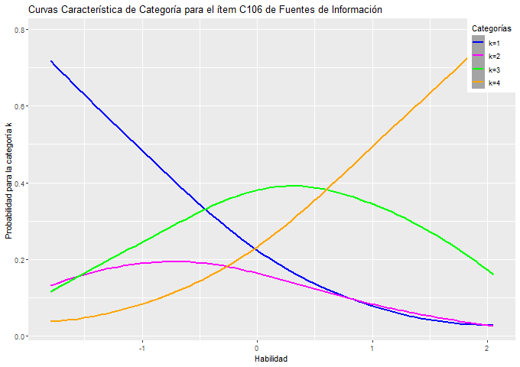

## C107

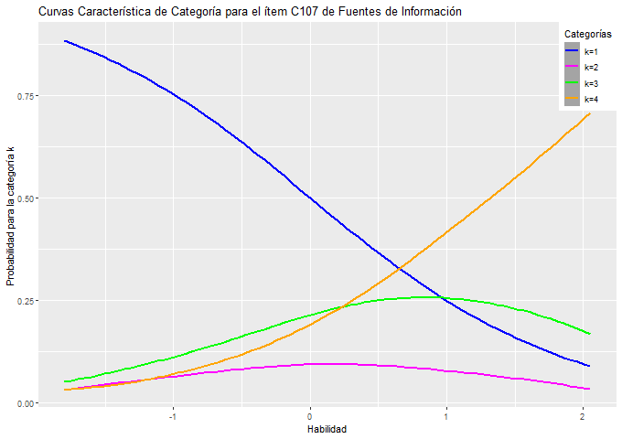

## C108

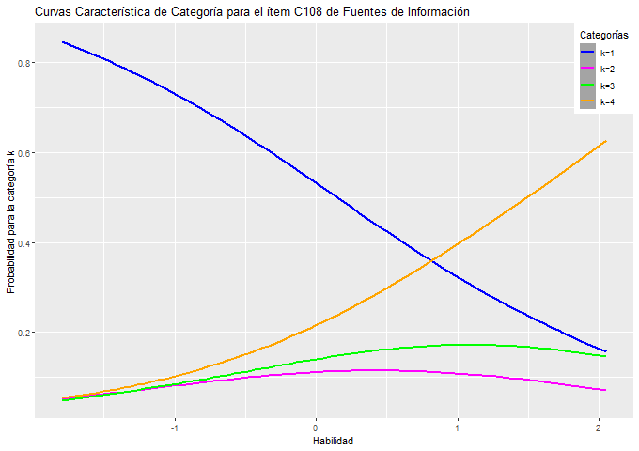

# **IICs Item de Informacion**

